**TRICLINIC** 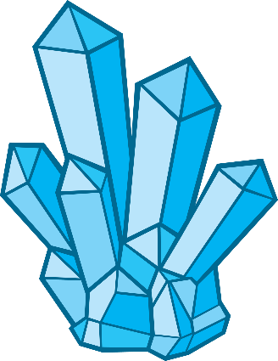

There are a total of seven crystal Triclinic, Monoclinic, Orthorhombic, Tetragonal, Trigonal, Hexagonal, and Cubic. Diamond is the hardest natural material. The study of the diamond is known as Gemology Based on the three inclined angles the various forms of crystals are in the paired faces. Some standard Triclinic Systems include Labradorite, Amazonite, Kyanite, Rhodonite, Aventurine Feldspar, and Turquoise.

Pedial is also triclinic hemihedral. Mineral examples include plagioclase, microcline, rhodonite, turquoise, wollastonite and amblygonite, all in triclinic normal.  It may also be described as face centered cubic lattice in which half of the tetrahedral sites are filled while all the octahedral sites remain vacant.

 All three angles intersect at right angles and are of equal length. Crystal shapes of a cubic system based on inner structure (square) include octahedron, cube, and Hexaciscoherdron. Example: Silver, Garnet, Gold, and Diamond.  It is formed in deep earth layers by compression of the mineral carbon under very high pressure. Gemstones can be cut and polished into beautiful shapes due to their composition and hardness.

The pinacoidal class has a center of symmetry. It is also called 'triclinic normal'. On the other hand, the pedial class has no symmetry.In crystallography, a crystallographic point group is a set of symmetry operations, corresponding to one of the point groups in three dimensions, such that each operation (perhaps followed by a translation) would leave the structure of a crystal unchanged i.e. the same kinds of atoms would be placed in similar .